**TITLE: BLOOD BANK MANAGEMENT SYSTEM**

INTRODUCTION

Blood bank is a place where blood bag that is collected from blood donation events is stored in one place. The

Term “blood bank” refers to a division of a hospital laboratory where the storage of blood product occurs and where

Proper testing is performed to reduce the risk of transfusion related events (Vikas Kulshreshtha, Sharad

Maheshwari).

Blood bank is a place where blood bag that is collected from blood donation events is stored in one place. The

term “blood bank” refers to a division of a hospital laboratory where the storage of blood product occurs and where

proper testing is performed to reduce the risk of transfusion related events (Vikas Kulshreshtha, Sharad

Maheshwari).

Blood bank is a place where blood bag that is collected from blood donation events is stored in one place. The

term “blood bank” refers to a division of a hospital laboratory where the storage of blood product occurs and where

proper testing is performed to reduce the risk of transfusion related events (Vikas Kulshreshtha, Sharad

Maheshwari).

Blood bank is a place where blood bag that is collected from blood donation events is stored in one place. The

term “blood bank” refers to a division of a hospital laboratory where the storage of blood product occurs and where

proper testing is performed to reduce the risk of transfusion related events (Vikas Kulshreshtha, Sharad

Maheshwari).

Blood bank is a place where blood bag that is collected from blood donation events is stored in one place. The

term “blood bank” refers to a division of a hospital laboratory where the storage of blood product occurs and where

proper testing is performed to reduce the risk of transfusion related events (Vikas Kulshreshtha, Sharad

Maheshwari).

Blood bank is a place where blood bag that is collected from blood donation events is stored in one place. The

term “blood bank” refers to a division of a hospital laboratory where the storage of blood product occurs and where

proper testing is performed to reduce the risk of transfusion related events (Vikas Kulshreshtha, Sharad

Maheshwari).

Blood bank is a place where blood bag that is collected from blood donation events is stored in one place. The

term “blood bank” refers to a division of a hospital laboratory where the storage of blood product occurs and where

proper testing is performed to reduce the risk of transfusion related events (Vikas Kulshreshtha, Sharad

Maheshwari).

Blood bank is a place where blood bag that is collected from blood donation events is stored in one place. The

term “blood bank” refers to a division of a hospital laboratory where the storage of blood product occurs and where

proper testing is performed to reduce the risk of transfusion related events (Vikas Kulshreshtha, Sharad

Maheshwari).

This project is aimed to developing an online Blood

Donation Information.

The entire project has been developed keeping in view of the distributed client server computing technology, in mind.

Blood bank is a place where blood bag that is collected from blood donation events is stored in one place.

The term “blood bank” refers to a division of a hospital laboratory where the storage of blood product occurs and where proper testing is performed to reduce the risk of transfusion related events

Blood Bank Management System (BBMS) is a web based system that can assists the information of blood bag

during its handling in the blood bank. With this system, the user of this system can key in the result of blood test that

has been conducted to each of the blood bag received by the blood bank. The result of test will indicate whether the

blood bag can be delivered to patient or not.

Blood Bank Management System (BBMS) is a web based system that can assists the information of blood bag during its handling in the blood bank.

With this system, the user of this system can key in the result of blood test that has been conducted to each of the blood bag received by the blood bank.

The result of test will indicate whether the blood bag can be delivered to patient or not.

From this system, there are several type of report that can be generated such as blood stock report, donor’s

gender report and the total of blood donation according to months and year. The system also can give the

information to the donor about blood analysis test result for each time the donor makes contribution. Hence, BBMS

will make the blood bank stock more systematic and manageable.

The system also can give the information to the donor about blood analysis test result for each time the donor makes contribution.

Hence, BBMS will make the blood bank stock more systematic and manageable.

ABSTRACT

This project is aimed to developing an online Blood Donation Information.

The entire project has been developed keeping in view of the distributed client server computing technology, in mind.

The Blood Donation Agent is to create an e-Information about the donor and organization that are related to donating the blood.

Through this application any person who is interested in donating the blood can register himself in the same way if any organization wants to register itself with this site that can also register.

Moreover if any general consumer wants to make request blood online he can also take the help of this site.

Admin is the main authority who can do addition, deletion, and modification if required.

The project has been planned to be having the view of distributed architecture, with centralized storage of the database.

The application for the storage of the data has been planned. Using the constructs of MS-SQL Server and all the user interfaces have been designed using the ASP.Net technologies

Image of page 1

Image of page 2

Image of page 1

OBJECTIVES

The purpose of the blood bank management system is to simplify and automate the process of searching for blood is case of emergency and maintain records of blood donars recipients ,blood donation programs and blood stocks in the bank.

1. To provide a means for the blood bank management system to publicize and advertise blood
2. To allow the probable recipients to make search and match the volunteer donars and make request for the blood.
3. To provide an efficient donar and blood stock management functions to the blood bank by recording the donar and blood details.
4. To improve the efficiency of blood stock management by altering the blood bank staffs when the blood quantity is below it par level or when the blood stock has expired.
5. To provide synchronized and centralized donar and blood stock database.
6. To provide immediate storage and retrieval of data and information.

SCOPE

This application is built such a way that it should suits for all type of blood banks in future.

Every effort is taken to implement this project in this blood bank,

DESCRIPTION OF TECHNOLOGY

The development of this new system contains the following activities , which try to automate the entire process keeping in the view of database integration approach.

This blood bank management system is an online website so it is easily available to change donar details, delete donar or change the password.

The purpose of the blood bank management system is to simplify and automate the process of searching for by recording the donar and blood details,

This project is aimed to developing an online Blood donation information,

The basic building aim is to provide blood donation service to the city recently.

Blood bank management system is helps to managing various blood bank operations

MAIN MODULES

This project have the following modules ,to manage all the requirements of the blood bank.

Online blood bank management system is to provide services for the people who are in the need of blood by getting help from the donars who are interested in donating blood for people

There are seven main modules in this syetm.

1.Admin

2.Donars

3.Donars registration

4.Modifying donar information

5.Acceptors

6.Donar search

Admin

Admin can mange both donars and acceptors.he can add or remove any user from the system.

Each member donar and acceptors is given a user id and password ,which identifies him uniquely . from admin module use can change donar details ,delete donar or change the password

.change password

.modify donar details

.delete donar details

.logout

2.Donars

From this module user can create their account,when user create his account the user get a user id and password which identifies him uniquely.

From this modules user can search donar for blood and can also refer his friend become a donar .

Donar can also get information like when he donated blood or when he will be able to donated blood

Donar registration

From this module people who are interested in donating blood get registered in my site and give his overall details

Related to him , he fills in a registration from by giving the total details such as name,address,city,blood group,phone no,email address, etc.

He was also given two fields username,and password,to such that he was a registered donar and he can enter the login form with his username and password and can modify his details if needed.

Modifying donar information

The registered donar only is able to modify his details as there was afoem which restricts others from entering the username and password providing high security for the details given by donar.

.1 Find A donar

.2 Change password

.3 Logout

.4 why donate blood

Acceptors

This module helps user to find blood group.when user click on find a blood group system ask him to entry blood group he want to search.

After entering the blood group,system search for the availability of the blood group give him the list of the donars who has the same blood group.

Whenever a user wants to change password he select the change password option.

.1 Find A donar

,2 Change password

,3 Find a blood group

.4 Logout

FLOW DIAGRAM

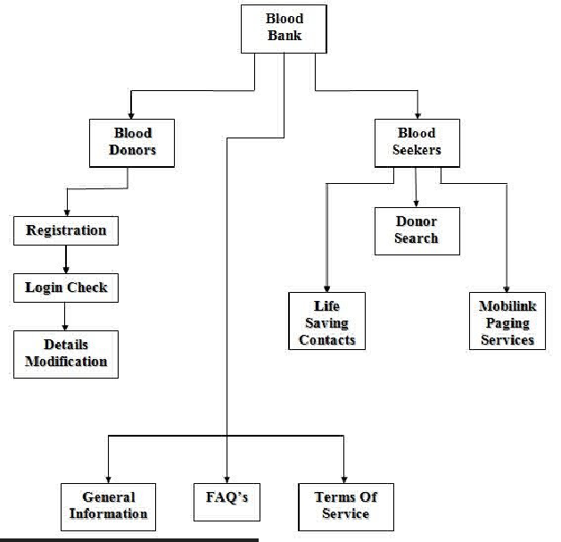

Donar Flow-Diagram

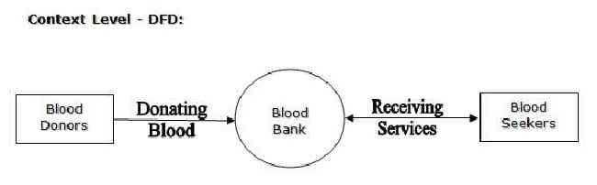

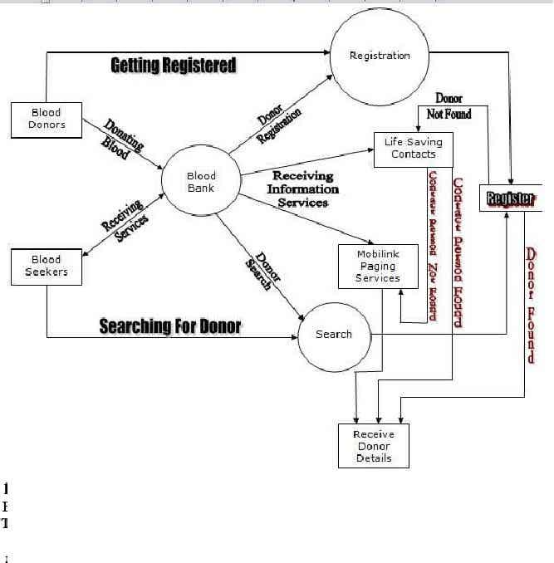

HARDWARE REQUIREMENT

1. PROCESSOR : Intel core duo 2.0 GHz or more
2. RAM : 1GB or more
3. HARDDISK : 80 GB
4. MONITOR : 15” CRT,OR LCD monitor
5. KEYBOARD : Normal or Multimedia
6. MOUSE : compatible

FRONT END: JAVA,JAVA SCRIPT,HTML,CSS

BACK END: MYSQL

OPERATIING SYSTEM: WINDOWS 10

PROJECT MEMBERS

1. CHANDRAKANT RAUT
2. POOJA KADAM
3. SIYONA RAHANE

REFERENCE:

<https://www.academia.edu/17573428/Online_Blood_Donation_management_System_report>

<http://portal.scitech.au.edu/darun/wp-content/uploads/2017/07/Senior_ReportFINAL.pdf>

<https://www.slideshare.net/JawharAli/full-report-on-blood-bank-management-system>

**CONCLUSION:**

This report presents the blood bank management system related issues

The project application will be coded using languages such as:

JavaScript, java

The main objective of blood bank is to develop an emergency application for people who needs blood by using altering system.